**HJD Converter Plug-In**

The Heliocentric JD (HJD) converter plugin allows observations in previously loaded non-Heliocentric datasets to be selected for conversion to HJD. **NOTE: The HJD conversion currently assumes JD only and does not convert BJD observations into HJD data.**

Install the HJD Converter plug-in by going to the *Tool* menu and selecting the *Plug-In Manager*. AAVSO login is required. Scroll to and select the Heliocentric JD Converter file reader and click Install. After installation, restart VStar.

As an example, go to VSX and download ASAS data for R Car. This will be a .txt file. Then, go to the VStar *File* drop down tab and select “New Star from ASAS File” and open the downloaded R Car file. This will give you:

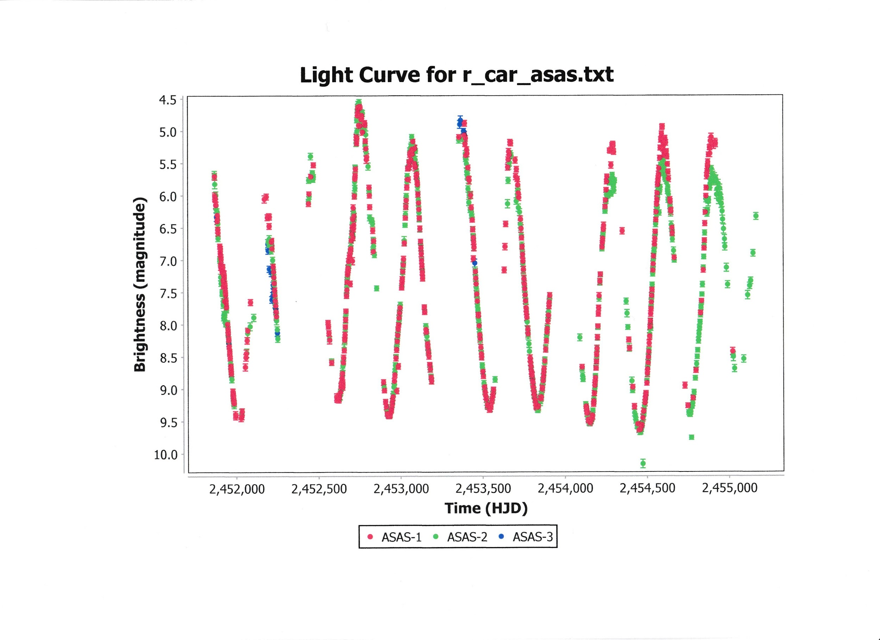

Next select “New Star from AAVSO Database”. Enter R Car in the “Star” field and replace Minimum JD with 2450500 and Maximum JD with 2451500. Check “Add to Current?” and click OK. This will yield the combined light curve:

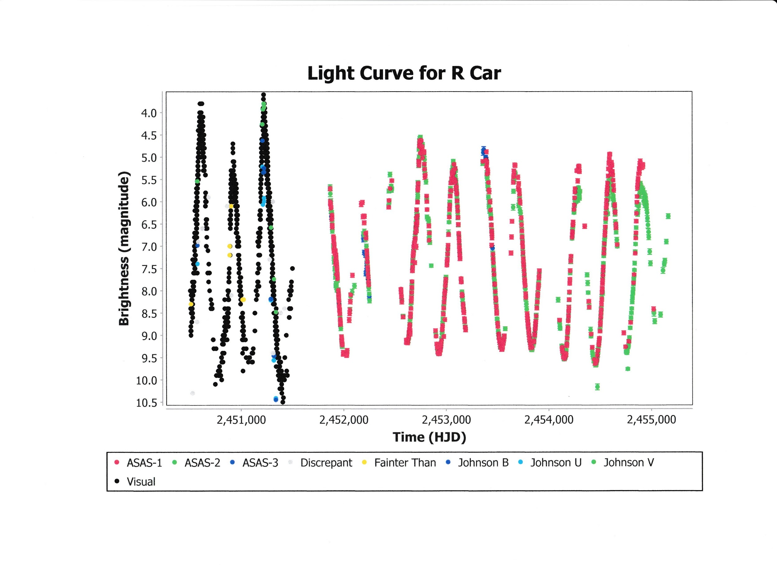

Go to the *Tool* drop down tab and select the “Heliocentric JD Converter” option. This yields the “Non-Heliocentric Datasets” window. Check the box for “AAVSO International Database observation source: R Car” and click OK. The “HJD Conversion” window will appear with the message “2228 observations converted”. Click OK.